Curriculum Vitae
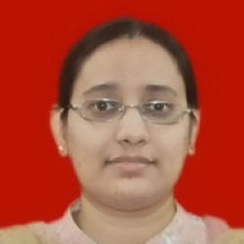

Name | - Prof. Nikhat S
Designation | - Assistant Professor
Educational Details | - Ph.D. Pursuing (Computer Engineering)  - M.E. (Computer Engineering)  - B.E (Computer Engineering)
Area of Specialization | - Artificial Intelligence  - Software Engineering  - Data Mining  - Data Structure
Teaching Experience | - 16 Years
Total Experience | - 16 Years
Paper Published in International Journals/Conferences | - 12
Books Published | - -
FDP / Conferences/ Workshops (Attended / Organized) | - 30
Certification Courses | - 12
Ph.D. Students Guided | - -
Ph.D. Students Currently Enrolled | - -
Membership of Professional Organizations | - 2
Contact Information | - Email: nikhat.shaikh@thadomal.org

